LEAD SCORING CASE STUDY USING LOGISTIC REGRESSION

SUBMITTED BY ~~:~~  Rajat Meshram

# CONTENTS





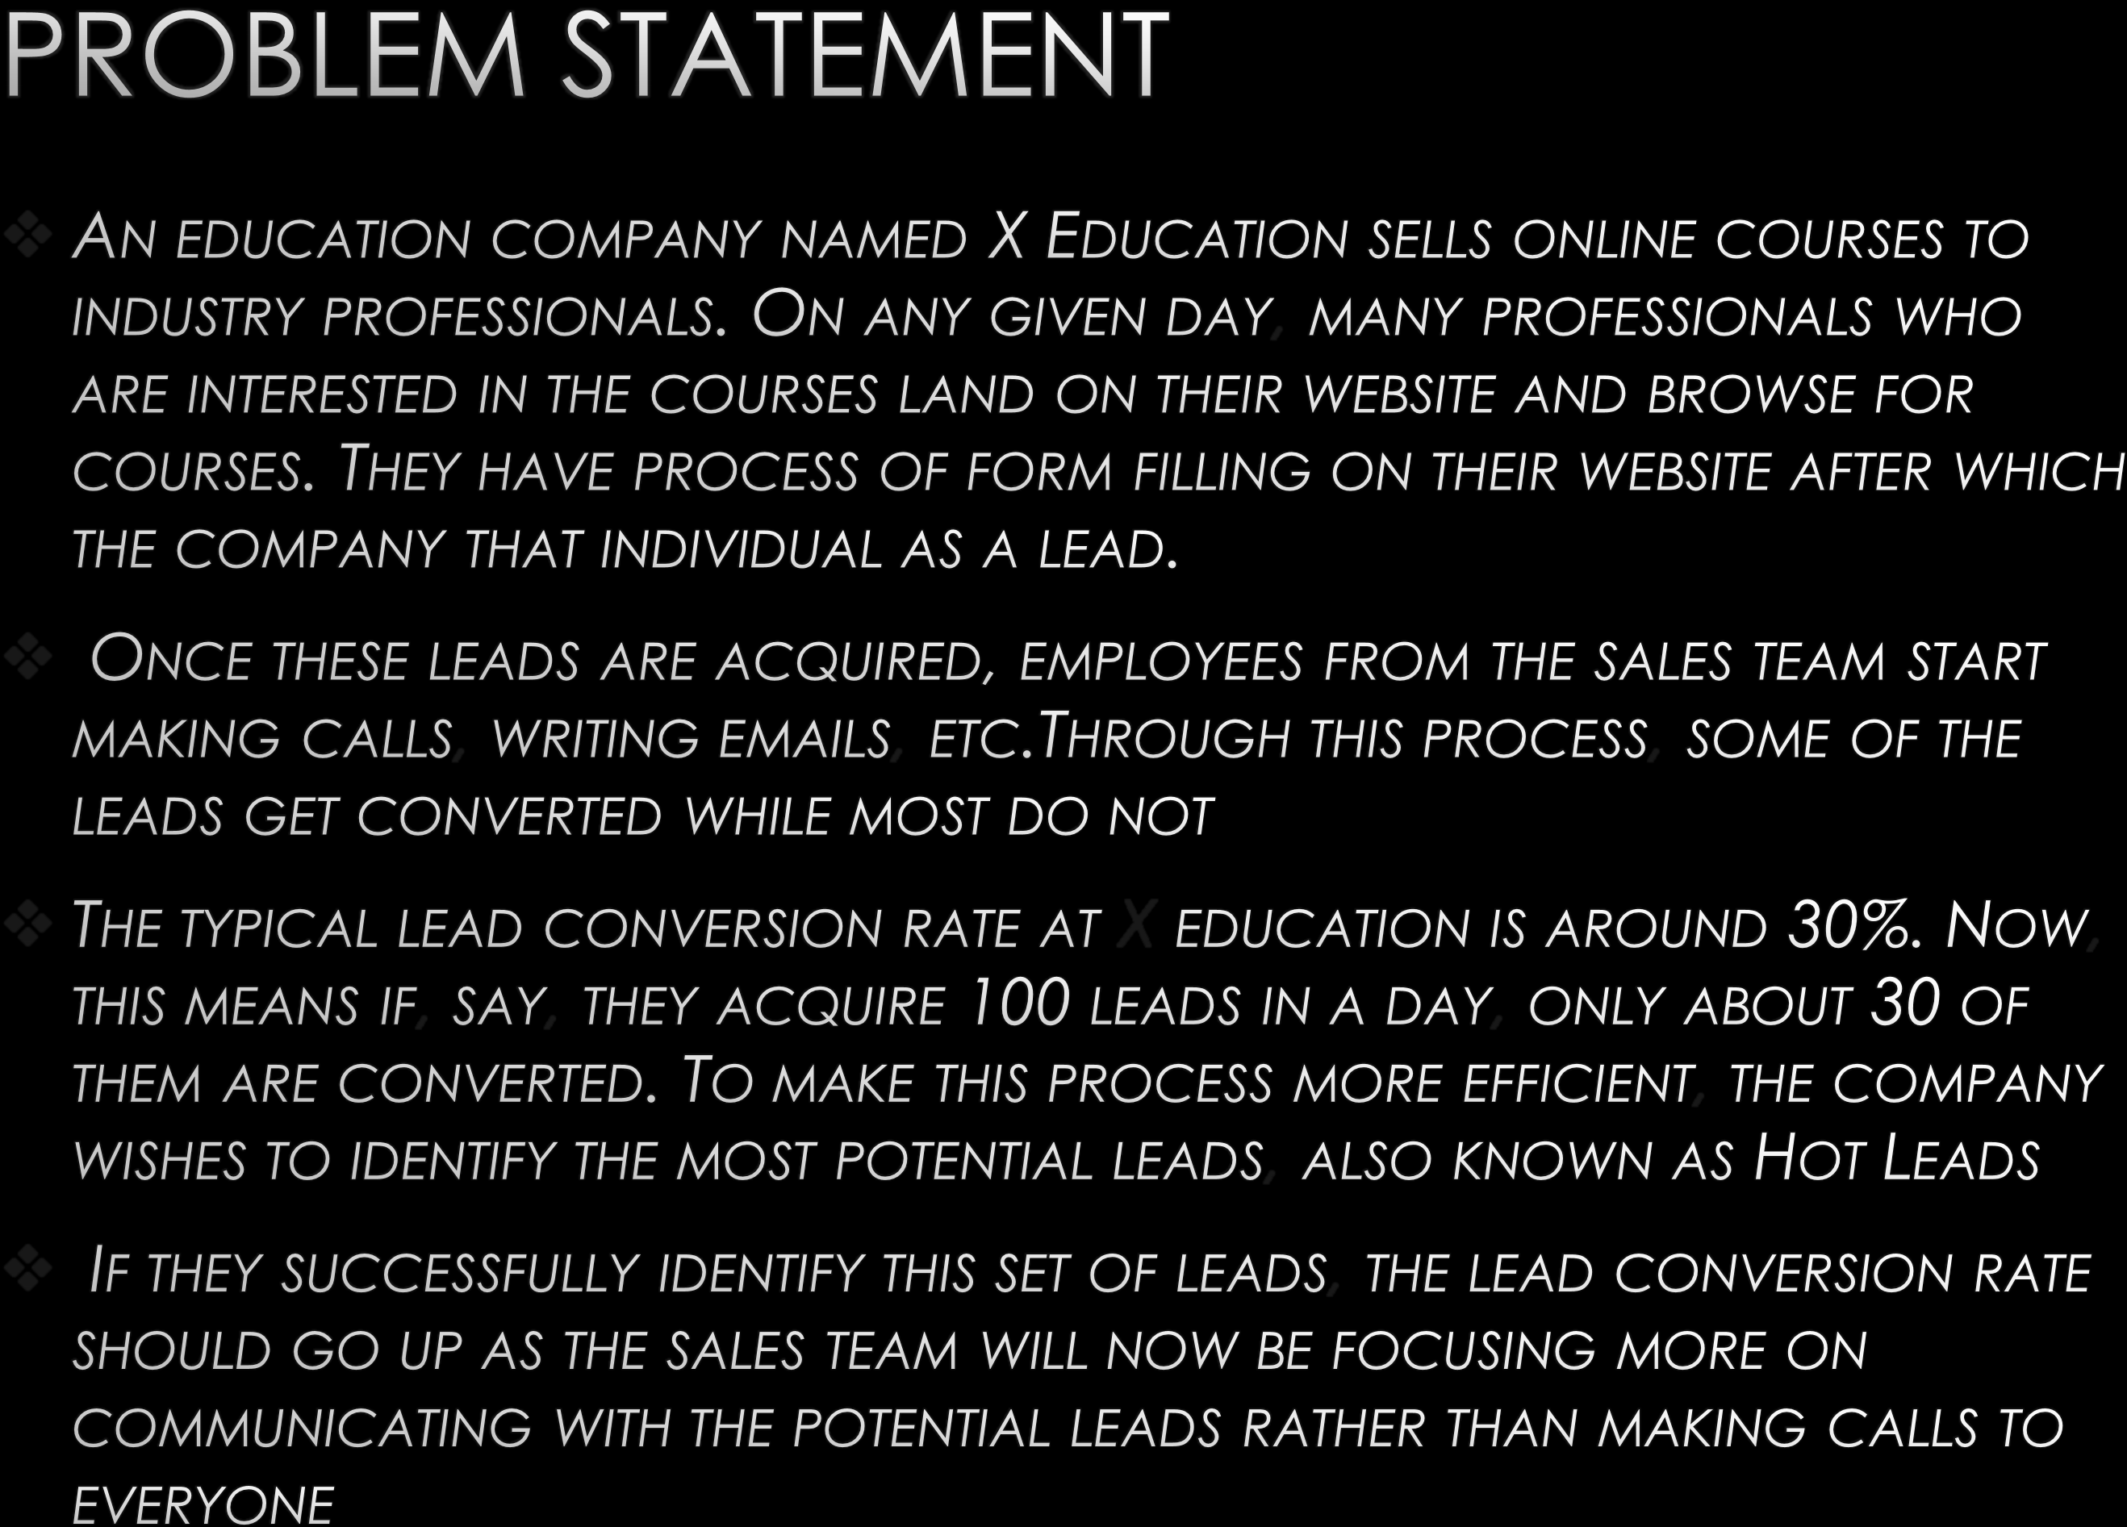PROBLEM STATEMENT

* AN EDUCATION COMPANY NAMED X EDUCATION SELLS ONLINE COURSES TO

INDUSTRY PROFESSIONALS. ON ANY GIVEN DAY, MANY PROFESSIONALS WHO

ARE INTERESTED IN THE COURSES LAND ON THEIR WEBSITE AND BROWSE FOR COURSES. THEY HAVE PROCESS OF FORM FILLING ON THEIR WEBSITE AFTER WHICH THE COMPANY THAT INDIVIDUAL AS A LEAD.

* ONCE THESE LEADS ARE ACQUIRED, EMPLOYEES FROM THE SALES TEAM START

MAKING CALLS, WRITING EMAILS, ETC.THROUGH THIS PROCESS, SOME OF THE LEADS GET CONVERTED WHILE MOST DO NOT.

* THE TYPICAL LEAD CONVERSION RATE AT X EDUCATION IS AROUND 30%. NOW,

THIS MEANS IF, SAY, THEY ACQUIRE 100 LEADS IN A DAY, ONLY ABOUT 30 OF

THEM ARE CONVERTED. TO MAKE THIS PROCESS MORE EFFICIENT, THE COMPANY WISHES TO IDENTIFY THE MOST POTENTIAL LEADS, ALSO KNOWN AS HOT LEADS.

* IF THEY SUCCESSFULLY IDENTIFY THIS SET OF LEADS, THE LEAD CONVERSION RATE SHOULD GO UP AS THE SALES TEAM WILL NOW BE FOCUSING MORE ON

COMMUNICATING WITH THE POTENTIAL LEADS RATHER THAN MAKING CALLS TO

EVERYONE

# BUSINESS OBJECTIVE



* 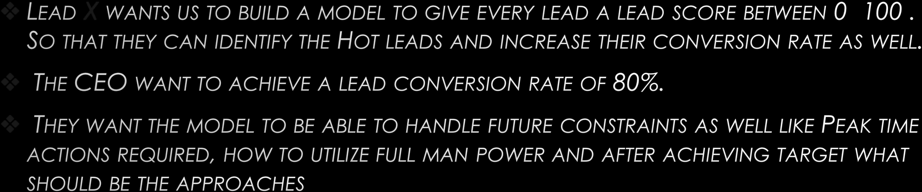LEAD X WANTS US TO BUILD A MODEL TO GIVE EVERY LEAD A LEAD SCORE BETWEEN 0 -100 .

SO THAT THEY CAN IDENTIFY THE HOT LEADS AND INCREASE THEIR CONVERSION RATE AS WELL. ❖ THE CEO WANT TO ACHIEVE A LEAD CONVERSION RATE OF 80 %.

* THEY WANT THE MODEL TO BE ABLE TO HANDLE FUTURE CONSTRAINTS AS WELL LIKE PEAK TIME

ACTIONS REQUIRED, HOW TO UTILIZE FULL MAN POWER AND AFTER ACHIEVING TARGET WHAT SHOULD BE THE APPROACHES.

PROBLEM APPROACH



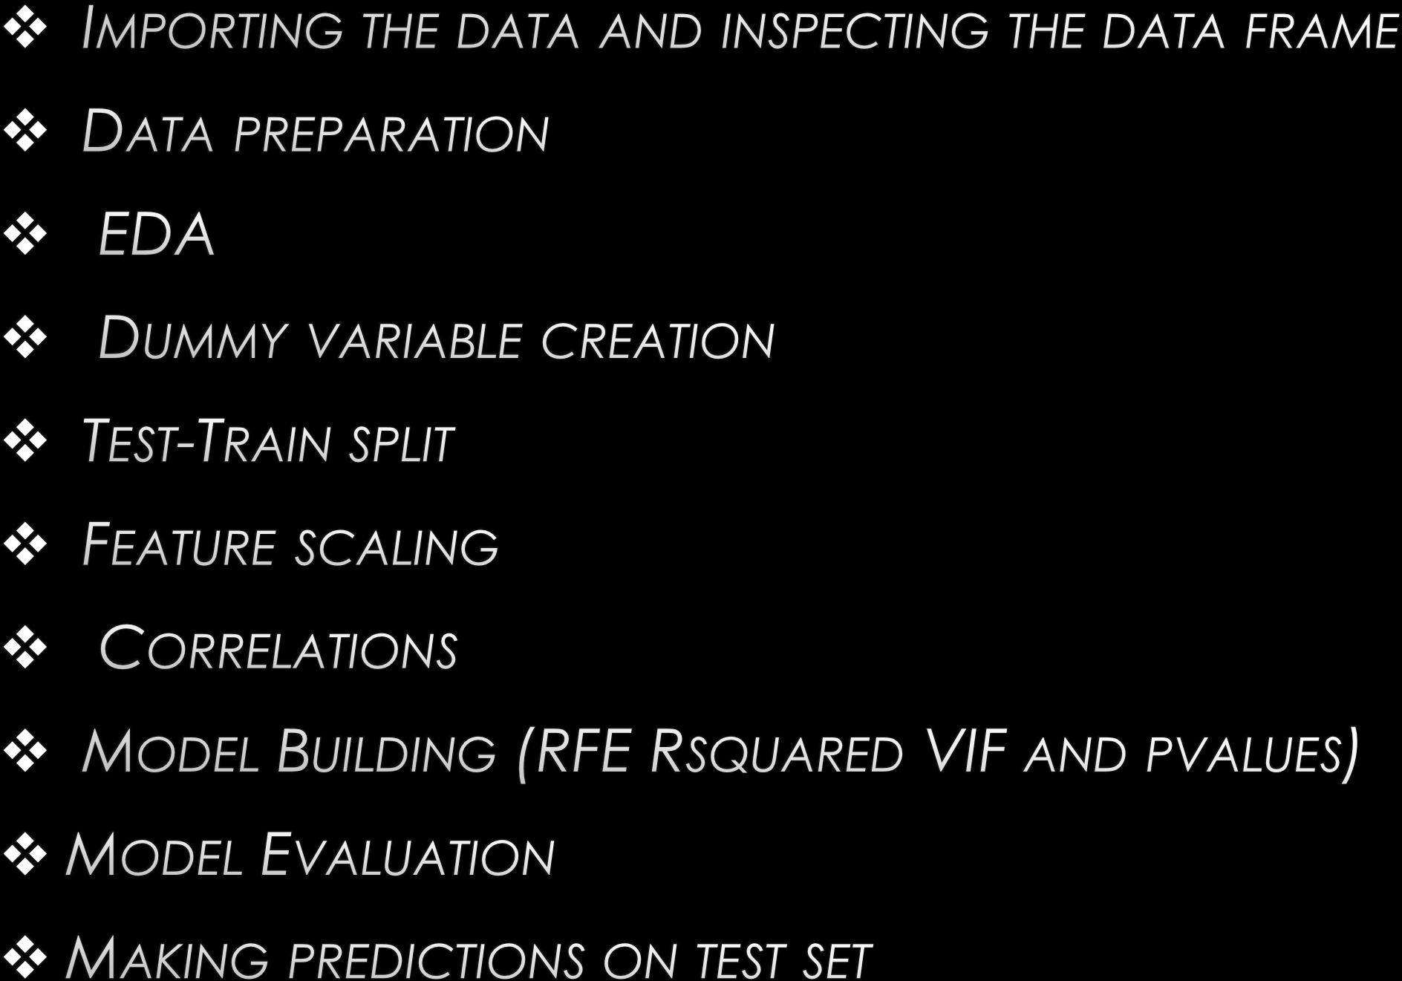

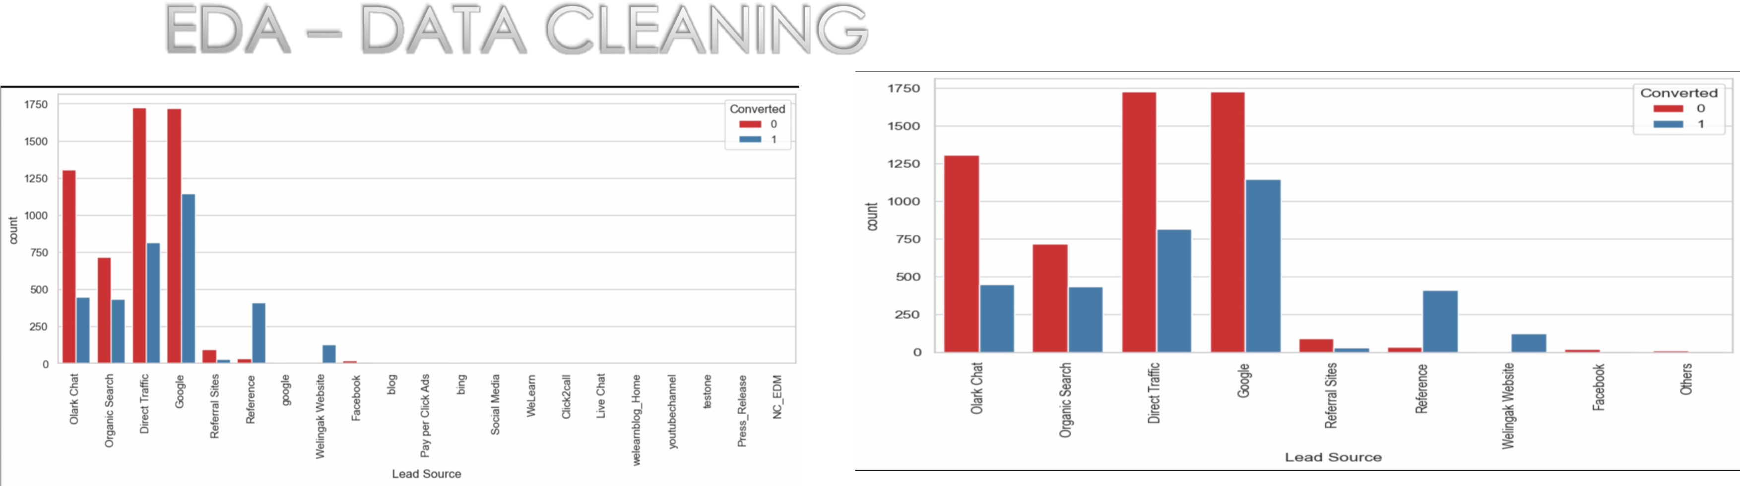

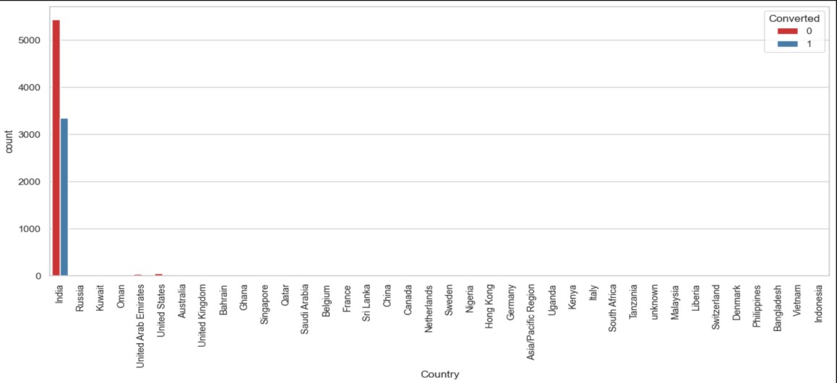

SPECIALIZATION

LEADS FROM HR, FINANCE & MARKETING MANAGEMENT SPECIALIZATIONS ARE HIGH PROBABILITY TO CONVERT

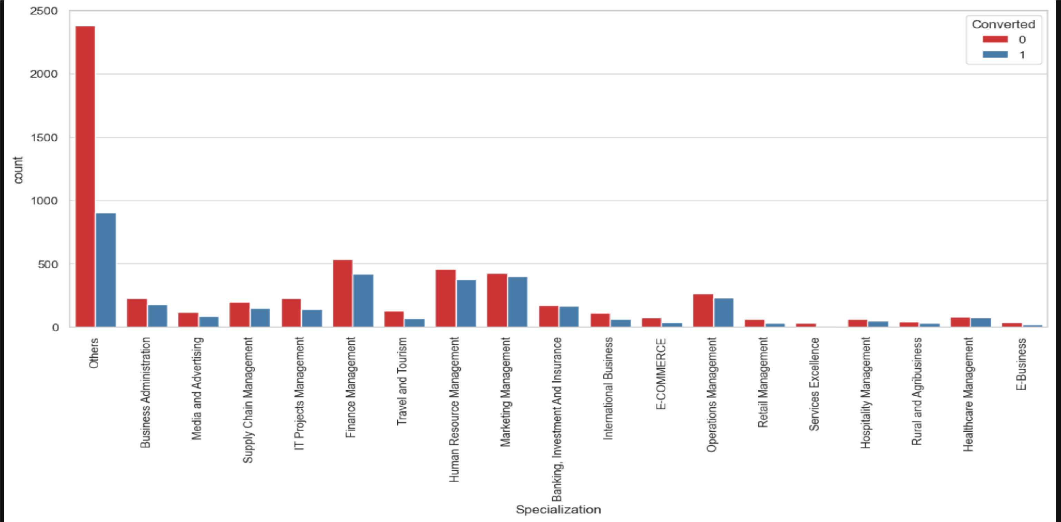

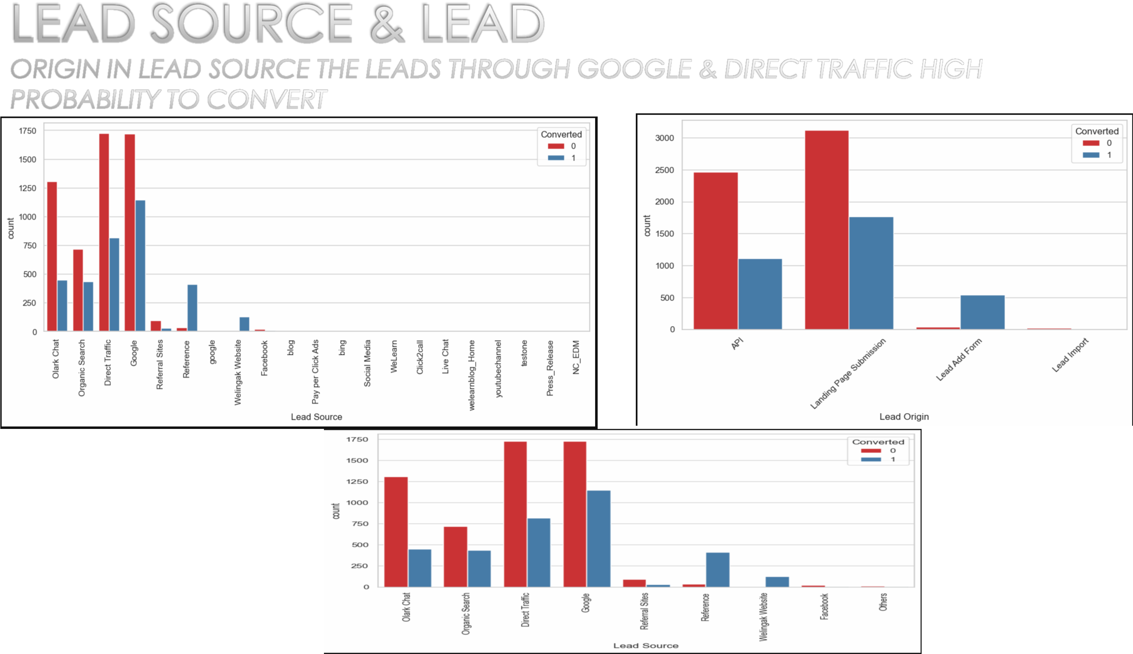

# LAST LEAD ACTIVITY



LEADS WHICH ARE OPENING EMAIL HAVE HIGH PROBABILITY TO CONVERT, SAME AS SENDING SMS WILL ALSO BENEFIT.

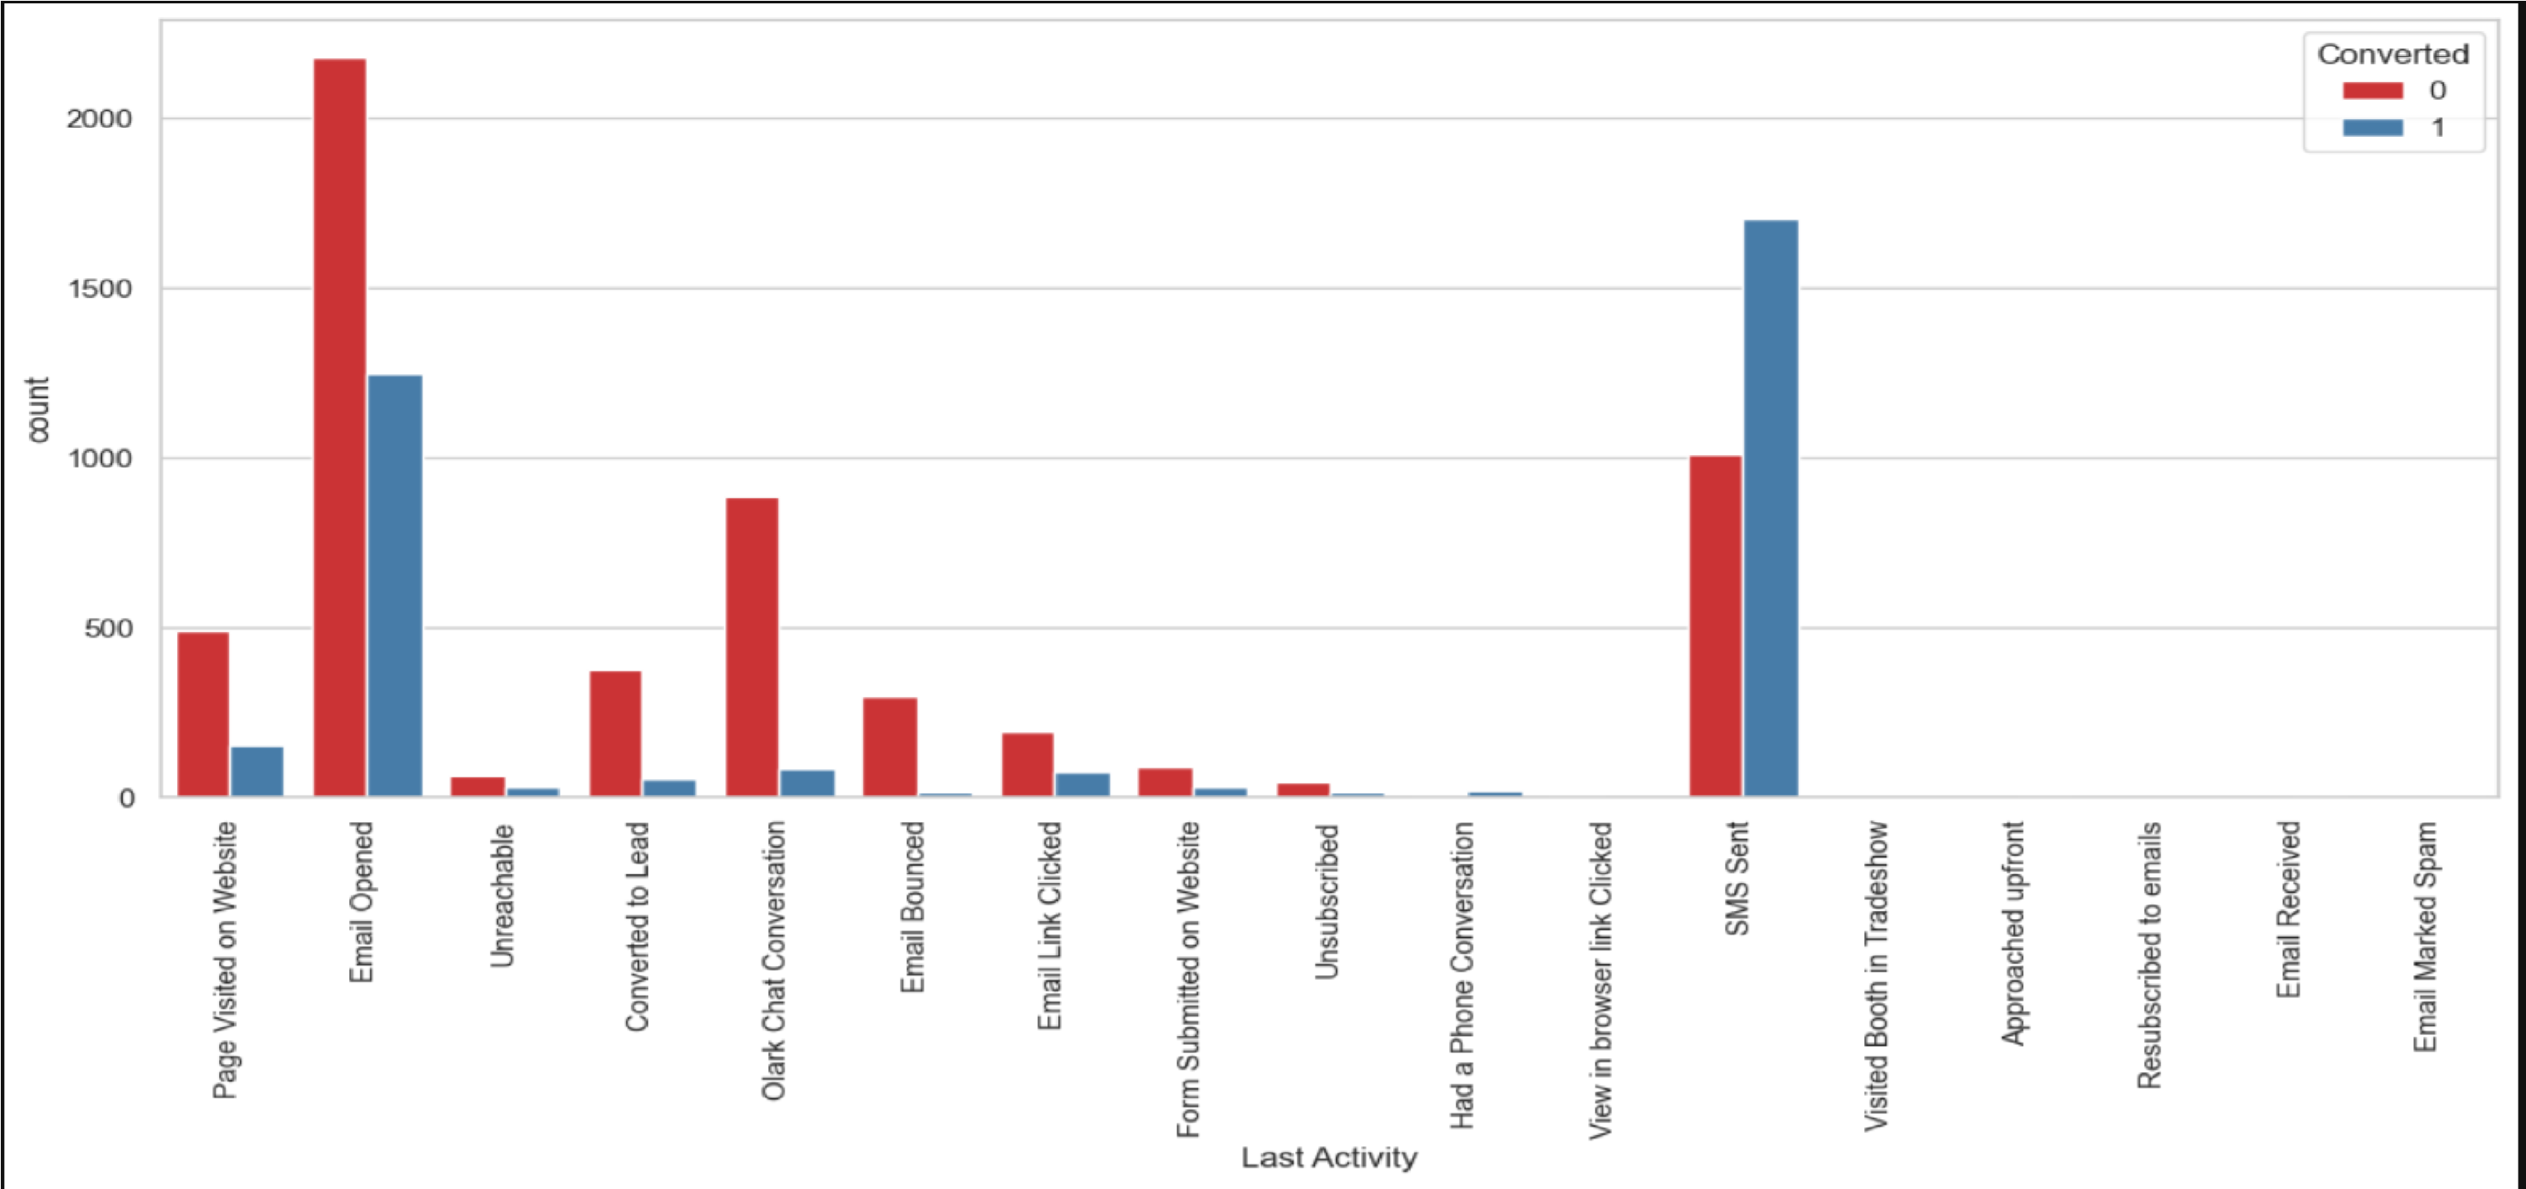

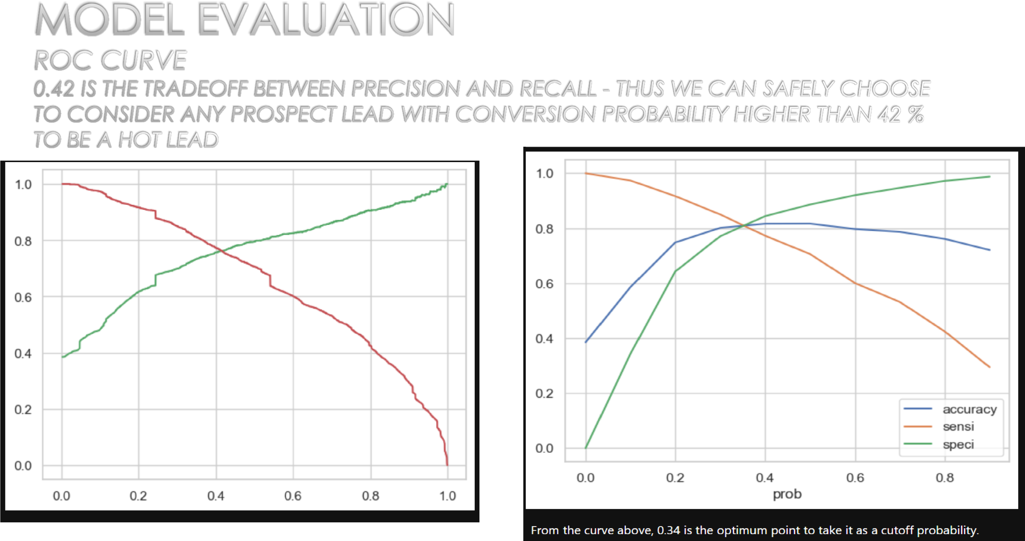

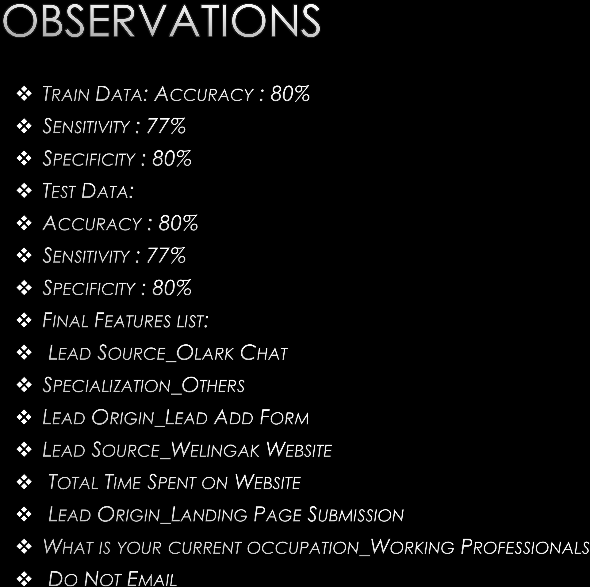

# CONCLUSION



* 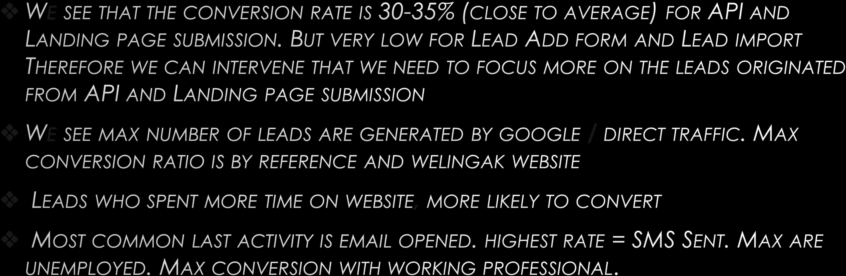WE SEE THAT THE CONVERSION RATE IS 30-35% (CLOSE TO AVERAGE) FOR API AND

LANDING PAGE SUBMISSION. BUT VERY LOW FOR LEAD ADD FORM AND LEAD IMPORT. THEREFORE WE CAN INTERVENE THAT WE NEED TO FOCUS MORE ON THE LEADS ORIGINATED FROM API AND LANDING PAGE SUBMISSION.

* WE SEE MAX NUMBER OF LEADS ARE GENERATED BY GOOGLE / DIRECT TRAFFIC. MAX CONVERSION RATIO IS BY REFERENCE AND WELINGAK WEBSITE.
* LEADS WHO SPENT MORE TIME ON WEBSITE, MORE LIKELY TO CONVERT.
* MOST COMMON LAST ACTIVITY IS EMAIL OPENED. HIGHEST RATE = SMS SENT. MAX ARE UNEMPLOYED. MAX CONVERSION WITH WORKING PROFESSIONAL.